9/15/2025
Moiz Ansari [23i-0523]

High Performance Computing with GPUs
HPC Assignment 1
Submitted to: Dr. Imran Ashraf
Submitted by:
Table of Contents
1 Introduction 2
2 Implementation Details 2
2.1 CPU Implementation 2
2.2 GPU Implementation 2
2.2.1 Memory Allocation and Transfer 2
2.2.2 1D Kernel Implementation 2
2.2.3 2D Kernel Implementation 3
2.3 Result Verification 3
3 Performance Analysis 3
3.1 Measurement Setup 3
3.2 Results Table 4
3.2.1 1D Kernel 4
3.2.2 2D Kernel 4
3.3 Graphs 4
3.3.1 Graph 1: Kernel execution time vs. matrix size 4
3.3.2 Graph 2: Total GPU time vs. matrix size 5
3.3.3 Graph 3: Speedup vs. matrix size 5
4 Analysis and Observations 5
4.1 CPU vs. GPU 5
4.2 1D vs. 2D Kernel 5
4.3 Different GPUs (Colab vs. Lab GPU) 6
5 Conclusion 6

Introduction
The purpose of this assignment is to implement and analyze matrix multiplication on both CPU and GPU using CUDA, comparing execution time, data transfer, and speedup. GPUs exploit massive parallelism, while CPUs handle mostly serial tasks, making them less efficient for large-scale matrix operations.
Experiments were performed on both Lab GPU and Google Colab GPU, for matrix sizes ranging from 256x256 to 2048x2048, measuring CPU time, GPU time (kernel + transfers), and speedup using CUDA events, which are presented through tables and graphs.

Implementation Details

CPU Implementation
The matrix multiplication code for CPU execution is implemented using 3 nested loops in C. The first two loops iterate over the rows one first matrix and columns of second matrix, whereas the third loop calculates the dot product of them by iterating over each element of the row-column pair.
This method results in time complexity of O(n³) for an n x n matrix. This is a simple approach and works normally for small matrices, but not suitable for large values of N, as it becomes significantly slower as matrix size increases.

GPU Implementation
The GPU version of matrix multiplication was implemented using CUDA. The implementation involved explicit memory management, kernel launches, and the use of both 1D and 2D kernel configurations.

Memory Allocation and Transfer
For GPU implementation, first, memory was allocated in the device for all matrices A, B and C using cudaMalloc. Then, the input matrices A and B were initialized on host memory and were transferred to device using cudaMemcpy. Then after the kernel execution, the result matrix C was transferred back to host memory using cudaMemcpy. CUDA events were used to measure the time for host-to-device transfer, device-to-host transfer, kernel execution, and total GPU execution time.

1D Kernel Implementation
In the 1D kernel implementation, a linear thread index was computed as index = threadIdx.x + blockIdx.x * blockDim.x. The index was then mapped to 2D coordinates: row = index / N, col = index % N. Each thread computed a single element C[row][col] by performing the dot product of the corresponding row of A and column of B.
Grid and Block Configuration:
- Number of threads per block: 512
- Number of blocks per grid: (N * N) / threadsPerBlock
Out of all the sizes, 512 threads per block gave the best results on all sizes of matrices.

2D Kernel Implementation
In the 2D kernel implementation, row and column indices were directly computed from block and thread coordinates:
row = threadIdx.x + blockIdx.x * blockDim.x
col = threadIdy.y + blockIdy.y * blockDim.y
Each thread computed a single element of the result matrix C[row][col].
Grid and Block Configuration:
- Number of threads per block: threadsPerBlock (32, 32)
- Number of blocks per grid: (N + threadsPerBlock - 1) / threadsPerBlock
The improvement of performance on 32x32 threads per block was observable on larger matrices so that’s why this size was selected.

Result Verification
After the computation of matrix multiplication on CPU and GPU, the results are then passed inside the verification function. This function checks if the difference of both results is no more than 1e-4, which is the tolerance of error. In my implementation, all results were matched successfully.

Performance Analysis

Measurement Setup
- Cuda Events for Time Recording
To measure execution times accurately on the GPU, CUDA events (cudaEvent_t) were used. CUDA events provide timestamps directly from the GPU, ensuring that measurements are not affected by CPU–GPU synchronization delays.
- Measured Metrics
The following timings were recorded for each experiment:
CPU execution time: Time taken by sequential CPU execution of matrix multiplication.
Data transfer device-to-host (D2H): Time taken to copy initial matrices from device to host memory.
GPU kernel execution time: Time taken by CUDA kernel to perform matrix multiplication on GPU.
Data transfer host-to-device (H2D): Time taken to copy results from host to device.
Total GPU time: Total time taken by GPU (D2H + Kernel + H2D).
- Experimental Conditions
Both kernel 1D and 2D configurations were tested. The experiment was performed repeatedly to calculate the average of all results and exclude the outliers caused by unconditional factors. The experiment was performed on both Lab GPU and Google Colab GPU for comparison.

Results Table

1D Kernel
Size | Avg CPU | Avg H2D | Avg Kernel | Avg D2H | Avg Total GPU | Speedup Kernel | Speedup Total
256 | 80.8135 | 0.1871 | 0.2809 | 0.2269 | 0.7311 | 287.6760 | 110.5440
512 | 752.3635 | 0.7139 | 1.0307 | 0.8086 | 2.5906 | 729.9876 | 290.4261
1024 | 8589.8392 | 1.9870 | 7.2635 | 2.9672 | 12.2387 | 1182.6079 | 701.8599
2048 | 106289.8328 | 7.8532 | 54.5959 | 11.8298 | 74.1903 | 1946.8449 | 1432.6652

2D Kernel
Size | Avg CPU | Avg H2D | Avg Kernel | Avg D2H | Avg Total GPU | Speedup Kernel | Speedup Total
256 | 54.1199 | 0.1806 | 0.2565 | 0.2208 | 0.6924 | 210.9891 | 78.1656
512 | 756.5035 | 0.7037 | 1.0402 | 0.8170 | 2.5988 | 727.2904 | 291.0966
1024 | 8042.4562 | 1.9809 | 6.8934 | 2.9142 | 11.8434 | 1166.6934 | 679.0642
2048 | 101811.9594 | 7.6666 | 53.3128 | 11.7652 | 72.8345 | 1909.7101 | 1397.8533

Graphs

Graph 1: Kernel execution time vs. matrix size
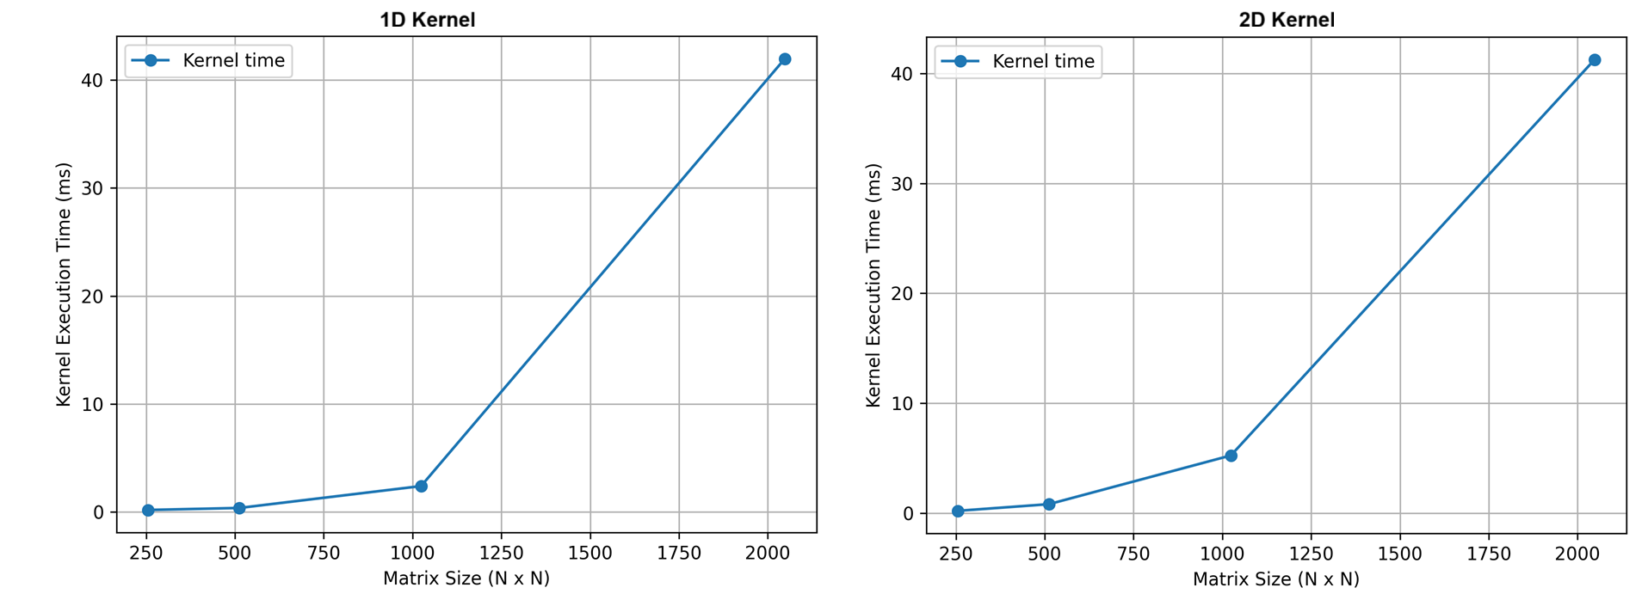

Graph 2: Total GPU time vs. matrix size
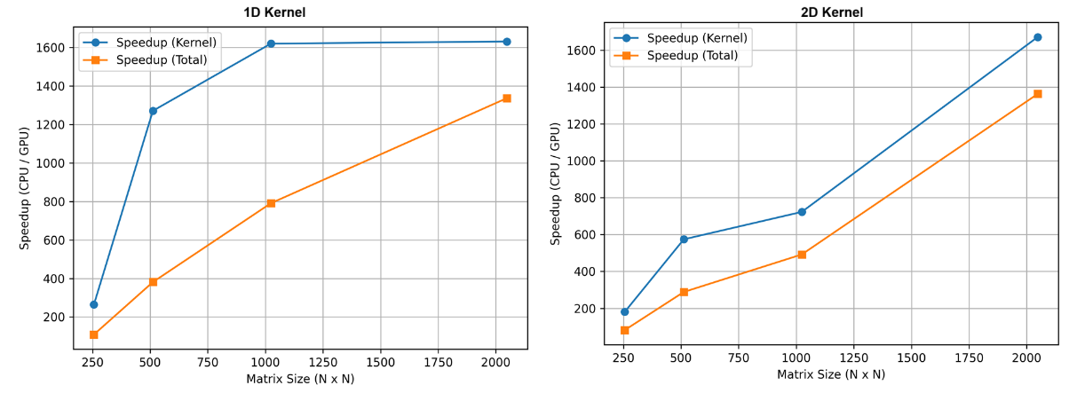

Graph 3: Speedup vs. matrix size
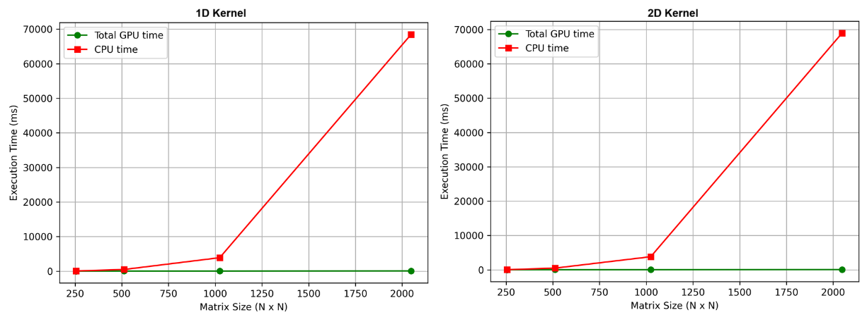

Analysis and Observations

CPU vs. GPU
For the starting values of N (like unto 32), the CPU and GPU performance difference is negligible and almost equivalent to each other. But as the value of N starts to increase, a significant amount of change can be observed in the efficient GPU performance compared to CPU performance. This is because for small sizes of matrices, the CPU might be competitive due to excessive memory transfer times for GPU.

1D vs. 2D Kernel
Size | 1D Kernel (ms) | 2D Kernel (ms) | Faster
256 | 0.2809 | 0.2565 | 2d
512 | 1.0307 | 1.0402 | 1d
1024 | 7.2635 | 6.8934 | 2d
2048 | 54.5959 | 53.3128 | 2d
From the table we can observe that 2D kernel is slightly faster than 1D kernel, but this difference increases as the size of matrices increases. The reason is that 2D mapping matches matrix layout naturally, so the threads in same wrap access consecutive memory easily. In addition, the 1D kernel wastes parallelism because it must compute row = index / N, col = index % N, which adds extra division/mod operations.

Different GPUs (Colab vs. Lab GPU)
Size | Colab T4 Kernel (ms) | Lab GPU Kernel (ms) | Faster
256 | 0.2687 | 0.2081 | Lab
512 | 1.03545 | 0.6033 | Lab
1024 | 7.07845 | 3.8305 | Lab
2048 | 53.95435 | 41.6088 | Lab
Analysis of Results:
- For smaller matrix sizes, the kernel execution times are already very low on both devices, so the performance gap is not significant.
- For larger matrix sizes, the Lab GPU consistently outperforms the Tesla T4. This advantage comes from its greater parallelism (more CUDA cores/SMs) and higher memory throughput, which help sustain the heavy computational and memory demands of large-scale matrix multiplication.
Reflection:
- The algorithm of code remains same, yet the hardware architecture impacts directly on the performance.
- GPUs with higher core counts and bandwidth deliver significant improvements for large workloads, demonstrating that both algorithm design and hardware capability must be considered when analyzing performance.

Conclusion
The experiments clearly show that GPU acceleration provides significant speedups over CPU execution, especially for larger matrices. For small inputs (256, 512), the CPU was competitive due to GPU overheads (data transfers + kernel launch). However, beyond size 1024, the GPU consistently outperformed the CPU by large margins.
Among the two kernels, 2D kernel was generally faster than 1D kernel due to its natural row/column mapping and more efficient memory access.
Finally, hardware differences also played a role: the Lab GPU outperformed Colab’s Tesla T4 for larger matrices due to higher memory bandwidth and more SMs, showing how GPU architecture directly impacts performance.
Hence, GPU based matrix multiplication is most beneficial for larger workloads, with 2D kernels on high-performance GPUs giving the best results.

